User’s Manual

Eric DiGioacchino

Jay Kerbelis

Claudia Usis

Alan Benitez

**Launching the Client Program**

At the moment there is no standalone application to run, so you must launch the client application through a java IDE.

The preferred IDE is IntelliJ IDEA which can be found at:

https://www.jetbrains.com/idea/download/

After downloading and launching your favorite IDE – locate the UserApp class. This file contains the main function for the project.

You should be greeted by a prompt similar to the image below:

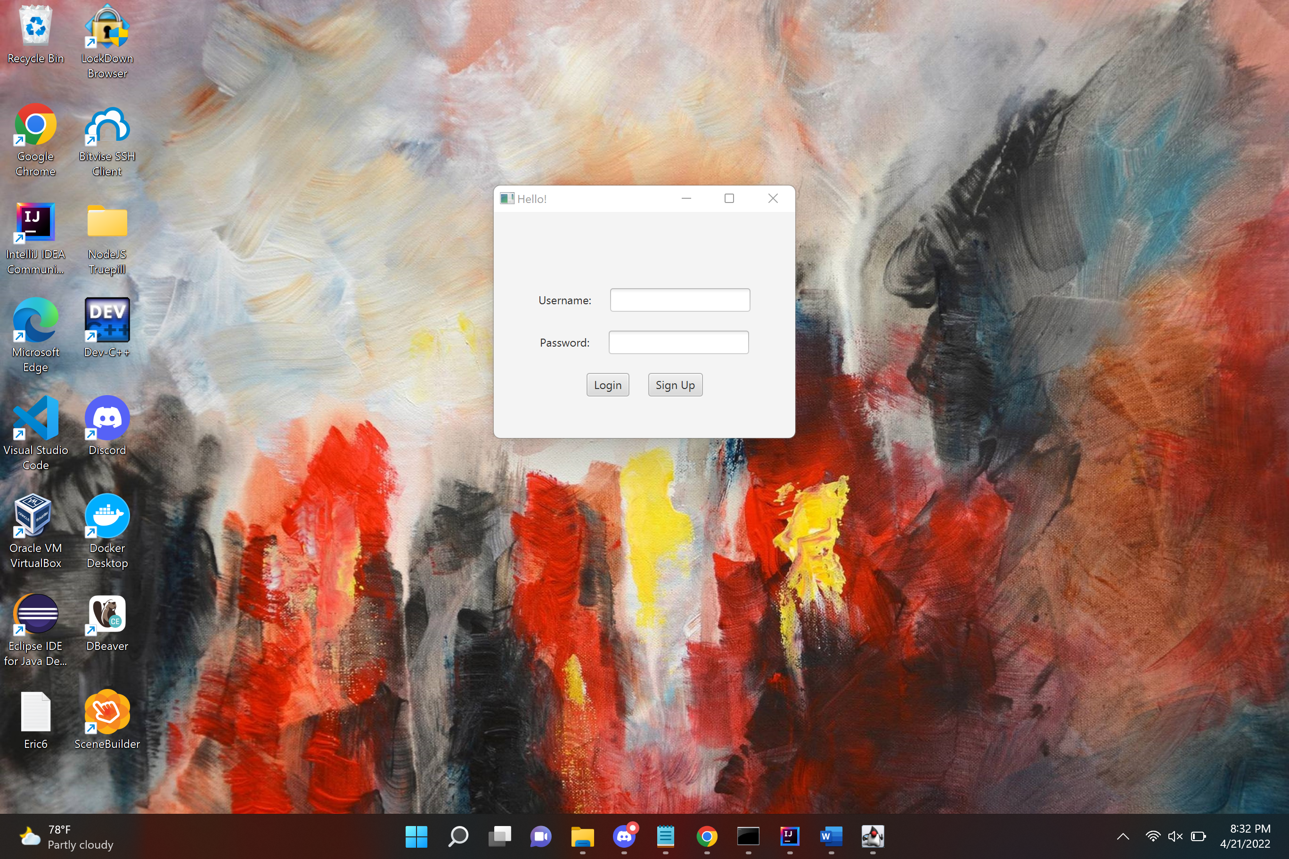

**Registration**

From the login page shown above, select – Sign Up.

Enter your information into the prompts on the ‘Sign Up’ page and complete your registration by selecting ‘Sign Up’ again.

**Create Notes**

As a new user you will see no notes in your account, just a large ‘+’ icon. Click the ‘+’ icon to create a new note.

If you should decide you didn’t want to create a new note, just leave the title field empty and the note will be deleted.

If you wish to save the note, it must have a title that is not empty and does not contain “Untitled”.

To exit a note, click the gray area outside the note frame.

**Delete A Note** – *In Progress*

While a user would ideally be able to select any number of notes at once to select and delete them, our program is currently not able to do so.

To delete a note, open the note, delete the title, and exit the note.

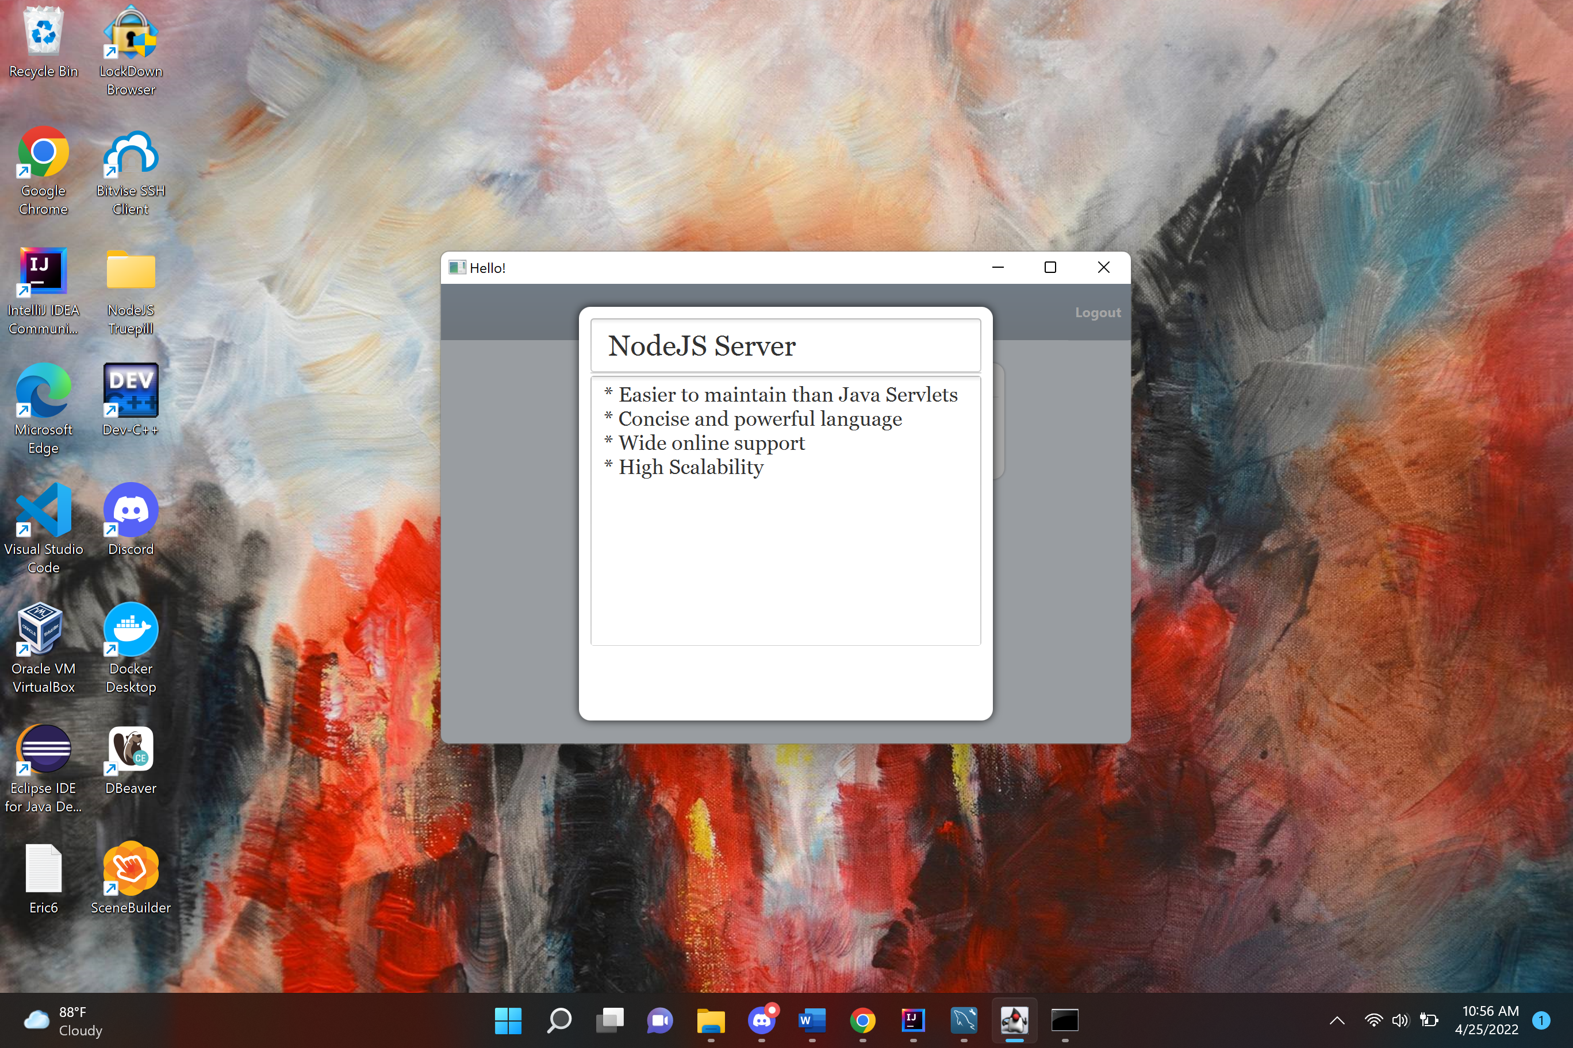

**Logging Out**

Logging out of the program is as simple as clicking the logout button, but don’t worry, exiting the window also logs the user out.